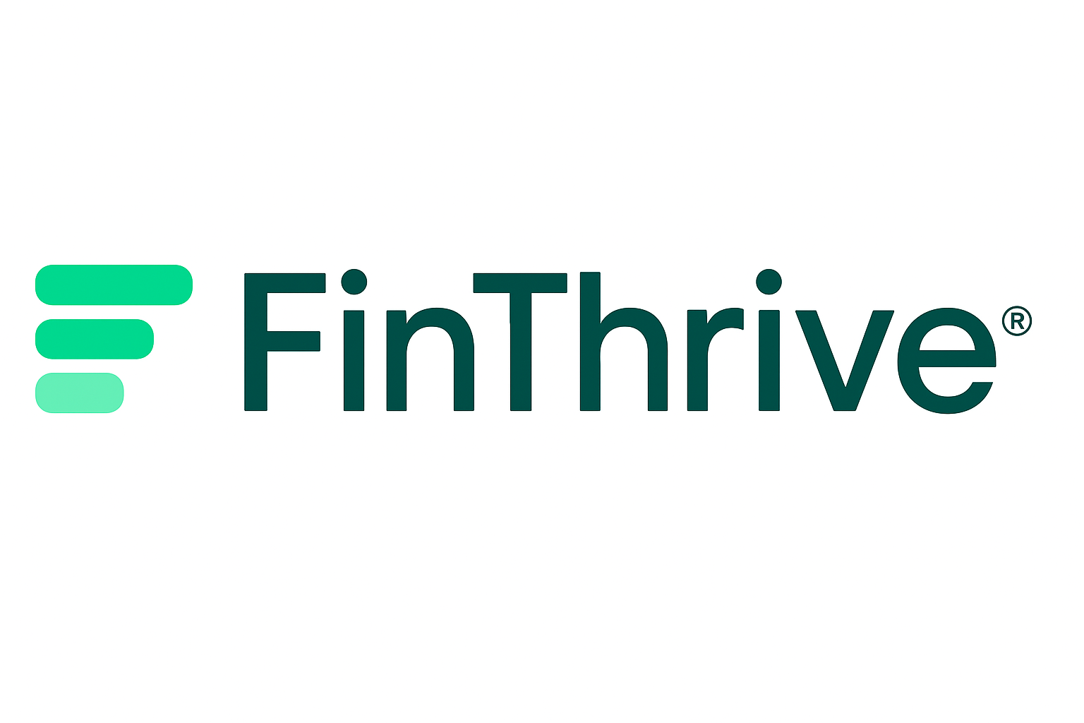

SELF‑ASSESSMENT REPORT 2025

College Name : Keshav Mittal
Employee ID : 409203
Email ID : Keshav.mittal@finthrive.com
Designation : Analyst
Date of Joining : 17th February 2025
Reporting Manager : Vikas Shah

TABLE OF CONTENTS
Content
TABLE OF CONTENTS…………………………………………………………………. 2
OVERVIEW OF PERFORMANCE………………………………………………………… 3
JOB KNOWLEDGE (EFFICENCY)……………………………………………………….. 4
RESULT ORIENTED (ACCURACY )……………………………………………………… 6
TEAMWORK…………………………………………………………………………………… 8
DISPLAYING FINTHRIVE VALUES………………………………………………………. 9
REWARDS & RECOGNITIONS…………………………………………………………… 11
TIME AWAY / LEAVE………………………………………………………………………… 12
FINAL RATING AND SUMMARY………………………………………………………….. 13
OVERVIEW OF PERFORMANCE
In 2025, my overall performance was average, with several ups and downs throughout the year. Even though the year presented challenges, I remained committed to maintaining consistency in my responsibilities and improving wherever possible. I made an effort to stay adaptable during shifting priorities and learned how to manage tasks under pressure while still meeting expectations.
One of the biggest highlights of the year was how quickly I adapted to the U.S. healthcare domain despite starting with no prior knowledge. I stepped into an entirely new area and made steady progress in understanding complex processes and requirements. Over time, I developed practical skills in credit balance, remit creation, analytics, and MBI generation. These areas allowed me to strengthen both my technical understanding and my confidence in performing daily tasks accurately and efficiently.
Beyond technical skills, I also improved my ability to navigate challenging situations, troubleshoot issues independently, and ask the right questions when needed. The experience helped me become more resourceful and better prepared to handle unfamiliar tasks. I also worked on improving communication and seeking support when required, which helped in maintaining steady progress throughout the year.
Overall, 2025 was a year filled with learning, self-improvement, and adaptation. Even though the performance had fluctuations, the year significantly strengthened my foundation in the healthcare domain and prepared me to perform with greater consistency, confidence, and accuracy moving forward.

JOB KNOWLEDGE (EFFICENCY)
Feb' 25 | Mar' 25 | Apr' 25 | May' 25 | June' 25 | July' 25 | Aug' 25 | Sep' 25 | Oct' 25 | Nov' 25 | Dec' 25
Government Reimbursement |  |  | 67.94% | 85.45% | 100.90% | 107.66% | 105.68% | 107.54% | 102.73% | 101.61%
 |  |  | Credit Balance Ramp

My efficiency data begins from February 2025, as that was the month I was onboarded. The initial months—February, March, and April—were spent working in the Government Reimbursement process. Even though I was completely new to the U.S. healthcare domain, I was able to understand the requirements quickly and deliver strong and consistent output during these early months. This period helped me build a foundational understanding of reimbursement rules, payer requirements, and the overall workflow.
In May (67.94%) and June (85.45%), my productivity experienced a temporary dip. This was primarily because I transitioned into more complex tasks and began learning additional areas such as Credit Balance Ramp, remit creation, analytics, and MBI generation. Since I had no prior knowledge of U.S. healthcare before joining, the learning curve naturally impacted productivity during these months. However, I continued to learn and adapt quickly.
From July onward, my efficiency showed a marked improvement and remained consistently above 100%, reflecting stronger job knowledge, improved task accuracy, and better familiarity with the process. The efficiency percentages demonstrate this steady upward trend:
- July: 100.90%
- August: 107.66%
- September: 105.68%
- October: 107.54%
- November: 102.73%
- December: 101.61%
These numbers highlight how quickly I was able to absorb new knowledge, adapt to unfamiliar tasks, and convert that learning into strong, reliable performance. As I gained more experience, I became more confident in handling credit balance analysis, identifying payer-related issues, generating MBIs accurately, and managing remits with improved precision.
Overall, my efficient journey in 2025 reflects steady growth, resilience, and a strong willingness to learn. Despite starting from zero knowledge in healthcare, I progressed quickly, delivered strong results in my initial process, and ultimately ended the year performing at a consistent and dependable level.

Feb' 25 | Mar' 25 | Apr' 25 | May' 25
Government Reimbursement |  |  | Credit Balance Training
RESULT ORIENTED (ACCURACY)

June' 25 | July' 25 | Aug' 25 | Sep' 25 | Oct' 25 | Nov' 25 | Dec' 25
92.17% | 97.61% | 99.78% | 89.32% | 97.75% | 97.67% | 93.64%
Credit Balance Ramp |  |  | Remit Creation Ramp |  |  | Analytics Live 1st Month
My accuracy throughout 2025 reflects a journey of learning, adaptation, and continuous improvement across multiple processes. Since I was onboarded in February 2025, my initial months—February, March, and April—were dedicated to the Government Reimbursement process. During this phase, I was able to deliver strong and consistent accuracy, even though the domain was completely new to me. This period helped build the foundation for understanding payer requirements, documentation flow, and reimbursement rules.
In May, I transitioned into Credit Balance training, which introduced new concepts and workflows. As expected, the transition led to a brief adjustment period, but I continued to perform steadily.
My accuracy results for the subsequent months demonstrate both my learning curve and my progression:
- June: 92.17% (Credit Balance Ramp – first full month working independently)
- July: 97.61%
- August: 99.78%
- September: 89.32% (Remit Creation Ramp – first month learning a new process)
- October: 97.75%
- November: 97.67%
- December: 93.64% (Analytics – first live month)
These numbers clearly show that whenever I transitioned to a new process, my accuracy initially dipped—which is expected when starting unfamiliar tasks. However, each time, I quickly recovered, improved, and reached strong accuracy levels within a short period.
Key Accuracy Insights:
- I consistently delivered above-standard accuracy once fully trained in the process.
- Dips in accuracy always aligned with transition periods and new responsibilities.
- I demonstrated the ability to learn new workflows quickly and bring accuracy back to expected levels.
- My strongest accuracy months were July, August, October, and November, showing stability and precision.
- Even handing three projects at same time (a more detailed and data-sensitive process), I maintained a 93.64% accuracy in my very first month.
Overall, my accuracy for 2025 reflects growth, adaptability, and continuous improvement. I consistently demonstrated the capability to understand complex processes, adjust quickly, and maintain high accuracy standards once familiar with the workflow.

TEAMWORK
Throughout 2025, I consistently demonstrated strong teamwork, collaboration, and a positive attitude while working across multiple processes. Even as I transitioned through Government Reimbursement, Credit Balance, Remit Creation, and Analytics, I ensured that I remained supportive, approachable, and actively engaged with team members.
One of my major contributions was performing Remit Creation sanity checks for the entire team throughout the month of October. This not only helped maintain accuracy across the group but also ensured timely identification and correction of potential errors. During this period, I introduced multiple new patterns and observations, which helped reduce team errors and improved overall consistency in our output.
I also supported new team members by sharing helpful shortcuts, patterns, and techniques to create remits more efficiently and with greater ease. I guided them in understanding the workflow, spotting common mistakes, and following the correct steps to avoid them. Additionally, I helped them identify HIPAA reason codes on EOBs, making their learning curve smoother and helping them become productive faster.
Beyond technical guidance, I made an effort to support the team’s overall experience. I communicated openly about challenges that multiple team members were facing and highlighted these issues on their behalf so they could be addressed collectively. This helped create transparency, improved mutual understanding, and encouraged better alignment with process expectations.
Throughout the year, I contributed to building a positive, friendly, and collaborative team environment. By bonding well with team members, staying approachable, and encouraging open communication, I played a role in making the workspace more comfortable and supportive for everyone.
Overall, my teamwork in 2025 reflected cooperation, mentorship, responsibility, and a genuine willingness to help others succeed.
DISPLAYING FINTHRIVE VALUES

Throughout 2025, I made a consistent effort to align my work, behavior, and mindset with FinThrive’s Purpose, Mission, Vision, and CARE values. Even as a new team member learning the U.S. healthcare domain for the first time, I ensured that my day-to-day actions reflected the culture and expectations of FinThrive.

Customer-Centric
I focused on delivering accurate and reliable work that supports our clients, patients, and internal teams. Whether working on Government Reimbursement, Credit Balance, Remit Creation, or Analytics, I prioritized quality and attention to detail because I understand that each task contributes directly to the value FinThrive provides. Even during my learning phases, I aimed to complete tasks in a way that minimized rework and ensured a better experience for downstream teams.

Agile
I adapted quickly to multiple process transitions throughout the year— Government Reimbursement, Credit Balance Ramp, Remit Creation Ramp, and Analytics. Despite having no prior U.S. healthcare experience, I learned rapidly and became comfortable with new tasks in a short timeframe. I also introduced new patterns during the October remit sanity checks, helping the team reduce errors and work more efficiently. My ability to shift, learn, and adjust demonstrates agility in both mindset and execution.

Reliable
I worked hard to build trust through consistency and accountability. From performing full-month remit sanity for the team, to assisting new team members, to maintaining above-standard accuracy and output once trained, I ensured that my work could be depended on. I also openly communicated challenges that the team was facing, helping leadership identify process gaps and areas for improvement.
Engaged
I remained actively involved with my team throughout the year—asking questions, providing support, sharing shortcuts and best practices, and helping new members understand HIPAA reason codes on EOBs. I also contributed to creating a positive and collaborative environment by building healthy working relationships with everyone. This engagement helped strengthen team morale, learning, and mutual support.

REWARDS & RECOGNITIONS
(Quarter 3- Rising Star Winners)

Rising Star- Recognizes new colleagues who have demonstrated outstanding performance, adaptability, initiative, and potential.
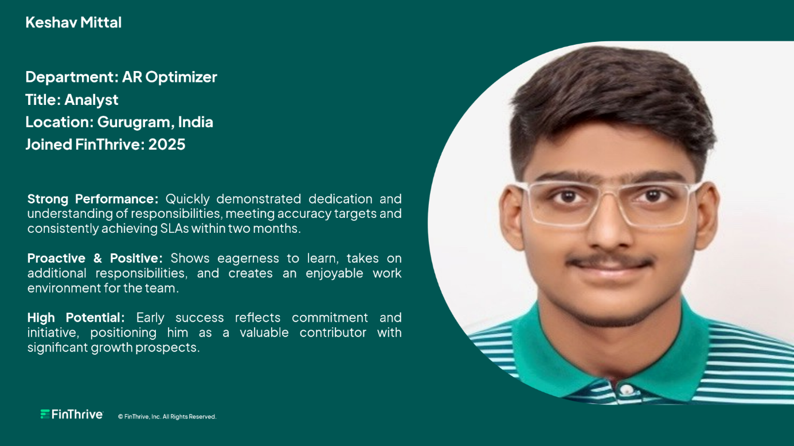
Supporting Document

TIME AWAY / LEAVE
MONTH | TOTAL LEAVES | LEAVE PERCENTAGE
FEBRUARY | 0 | 0%
MARCH | 0 | 0%
APRIL | 0 | 0%
MAY | 2 | 10.00%
JUNE | 1 | 4.76%
JULY | 2 | 9.09%
AUGUST | 1 | 5.00%
SEPTEMBER | 1 | 4.76%
OCTOBER | 2 | 9.52%
NOVEMBER | 2 | 10.00%
DECEMBER | 2 | 9.52%

Throughout the year, I maintained a controlled and responsible leave record, taking only the leaves that were genuinely necessary. My leave usage was balanced across the months, with 0 leaves taken during February, March, and April, and minimal leave numbers in the following months. The data shows that I consistently stayed within reasonable limits, for example, only 1 to 2 days of leave in months where leave was required, resulting in low team leave percentage contributions ranging from 4.76% to 10%. I did not take any unnecessary or avoidable leave, and I ensured that my time off did not disrupt teamwork. Whenever I took leave, I communicated in advance, managed responsibilities responsibly, and maintained reliability in my attendance throughout the year.

FINAL RATING AND SUMMARY
Efficiency % - 2
Accuracy % - 2 (AS PER GIVEN PARAMETERS)
In 2025, I demonstrated consistent growth, adaptability, and commitment while transitioning through multiple processes in the U.S. healthcare domain. Starting with no prior industry knowledge, I learned rapidly and built strong foundations in Government Reimbursement, Credit Balance, Remit Creation, and Analytics. Despite an early learning curve, I maintained an average yet steadily improving performance throughout the year and adapted effectively to changing responsibilities.
My efficiency data shows significant progression—from early-stage learning dips in May and June to consistently exceeding 100% productivity from July to December. Similarly, my accuracy reflected continuous development across processes; even when transitioning into new areas like Remit Creation and Analytics, I recovered quickly and delivered reliable results, reaching high accuracy levels month after month.
Teamwork was a key strength in 2025. I supported the team through full-month Remit sanity checks in October, introduced new patterns that reduced errors, mentored new members, and assisted them with shortcuts, workflow understanding, and identifying HIPAA reason codes. I also raised issues on behalf of the team to help streamline operations and contributed to maintaining a positive and collaborative work environment.
Throughout the year, I aligned my behavior and performance with FinThrive’s CARE Values—staying customer-centric, agile during process transitions, reliable in delivering consistent output, and engaged by actively supporting teammates and maintaining a strong work ethic.
My efforts were recognized through the Rising Star Award (Quarter 3), acknowledging my adaptability, initiative, and potential as a new colleague. Additionally, I maintained disciplined attendance with only 13 total leaves for the entire year, demonstrating responsible and controlled leave management.
Overall, 2025 was a year of strong learning, increasing confidence, and meaningful contribution. I built a solid foundation in multiple healthcare processes, supported my team, upheld FinThrive values, and delivered consistent performance with a clear trajectory of growth.

